State Resource Request System
(SRRS)
User Guide

UPDATE MARCH 2018

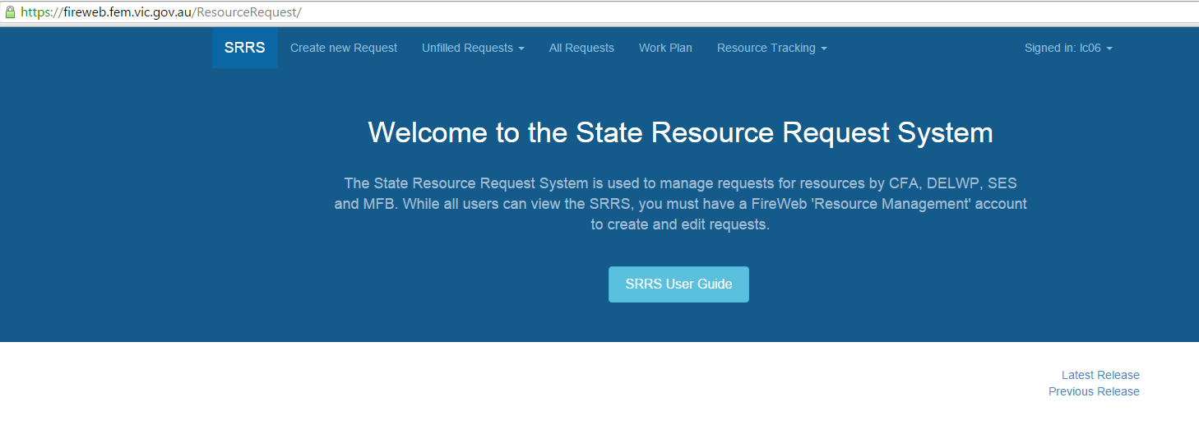

The State Resource Request System (SRRS) has been developed by
Technology Solutions Unit
Strategy, Capability and Innovation Division
Forest Fire Management Victoria
Level 13, 8 Nicholson Street
East Melbourne Vic 3002

Table of Contents

1. Introduction 3
2. Quick Start Guide 4
3. Starting SRRS 5
View Only Access 6
Add/Edit/Delete Access 6
4. Using SRRS – An Overview 7
Request Lists – Search for Unfilled Requests 8
5. Creating and Fulfilling Resource Requests and Generating Movement Orders 11
Overview 11
Step 1 - Create a New Resource Request - 12
Requesting Resources Officer Completes. (ICC,RCC,SCC that requires the resource) 12
Step 2 – Add Resources to Request - Requesting Resources Officer Completes 19
When choosing Add Resources, this screen displays: 19
COACHING AND MENTORING 23
Step 3 - Filling the Request- (Supplying Regions responsibility to complete) 24
Step 4 – Closing and Cancelling Requests 42
6. Reports Available in SRRS 42
Feedback and Support 44
Reference Material 44
Appendix 1 - Request Status Explained 45
Appendix 2 - example of a movement order 47

Introduction
An on-line application – the State Resource Request System (SRRS) exists:
- to manage the requesting, allocation and deployment of Incident Management Teams (IMT), Strike Teams, Task Forces and individual Specialist resources to major incidents
- for use by all emergency response agencies
- to assist Resource Units at all levels
SRRS is used where there are no resources available within the District footprint and resources need to be source from the broader Region or from across the State.

SRRS follows the resource requesting process outlined in Joint SOP J3.09– Resource Management, approved by DELWP, CFA, MFB, and SES. Additional information can be found in the Operational Resourcing Guideline and Aide Memoir, via the IMT Toolbox located through EMCOP, then Library.

The Region is then responsible for trying to fulfil the request from within the Region, across DELWP, CFA, MFB and SES- where resources can be sourced within the Region, the Movement Order is created and the resources dispatched.

Otherwise the request is escalated to the SCC, to be sourced from other Regions.
Role / Responsibility |  | Action
Requestor  No resources available within District footprint.  IMT Resources Officer create a request in SRRS |  | Creates a Request for Resources and advises RCC.
Broker  RCC- or if no resources available within Region, request forwarded to SCC |  | RCC – source resources within the Region, or forwards request to State.  SCC – source resources from other Regions, Interstate or International
Supplier  Supplying ICCs or RCC. | 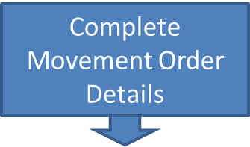 | Complete the Movement Order details. Publish the Movement Order
Disseminator of movement orders  RCC or SCC. |  | Distribute the Movement Order via EM Webmail to –  Requesting ICC Resources Officer and  ICC Logistics Officer  Supplying Regional Controller or delegated officer
At all stages in the process it is important to make sure that all conversations are recorded in the Record Call Details sections. This provides a history of actions that have been taken to fill the request.

Quick Start Guide
To create or edit requests, you must (a) be a registered Fireweb user with (b) role: Resource Management. You can access SRRS via

EM COP- http://cop.em.vic.gov.au log in, select Desktop, Sections, Resources, then select SRRS icon, 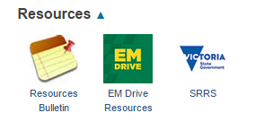
or
Fireweb – https://fireweb.ffm.vic.gov.au log in with role: Resource Management, click the red Resources menu item (left hand side), then click the SRRS link (top of the page) or,
Internet- type https://apps.ffm.vic.gov.au/login into your web browser’s address bar, then press [ENTER], click SRRS link and login
- Requests for additional resources (i.e. other than those already allocated to the incident) are made by creating a Resource Request in SRRS (by the IMT Resources Officer).
- Requests are then submitted to the Regional Controller (or their delegate), or Regional Resources Officer- who will attempt to source those requested resources from all agencies within the Region.
- Where resources can be sourced within the Region, a Movement Order is created and distributed to all interested parties (refer to matrix on page 3).
- Where resources cannot be sourced within the Region, the request is escalated to the State- to be sourced from other Regions, Interstate or International.
- SRRS is used for all emergency incidents as well as planned events or planned burns. For planned burns the District conducting the burn should request resources based upon their local ICC.
- All tasks you can perform in SRRS are commenced by clicking the menu options at the top of its home page
All requests follow this process:
  - Create a Request
  - Add the resource types required
  - Fulfil (source) the resources required
  - Create the movement order
  - Distribute/Disseminate the movement order documentation

Starting SRRS
There are several ways you can access/start SRRS:

- EM COP
- Into your web browser’s address bar type cop.em.vic.gov.au then press [ENTER]
- Click the Desktop tab, then the Sections tab
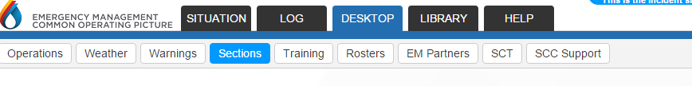
- Scroll to Resources then click SRRS icon
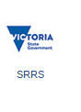
Note: This method takes you directly into the live system.
To access the training system use the Fireweb connection method below.

- Fireweb
- Into your web browser’s address bar type fireweb.ffm.vic.gov.au then press [ENTER] -Note you can access fireweb from the DELWP FFM Apps Login
- Click on the red Resources menu option (left hand side)
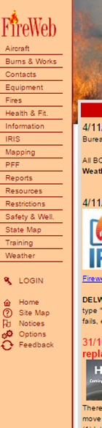
- Click on State Resource Request System at top of the page
Note- the blue section is the live system, while the green section is the training module

View Only Access
All Fireweb users have view only access to SRRS.

Add/Edit/Delete Access
To use SRRS, you must be assigned the Fireweb login role: Resource Management.

From the DELWP FFM Apps Login 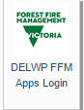 or Fireweb icon you will be asked to log in.
If this is your first time you will need to register

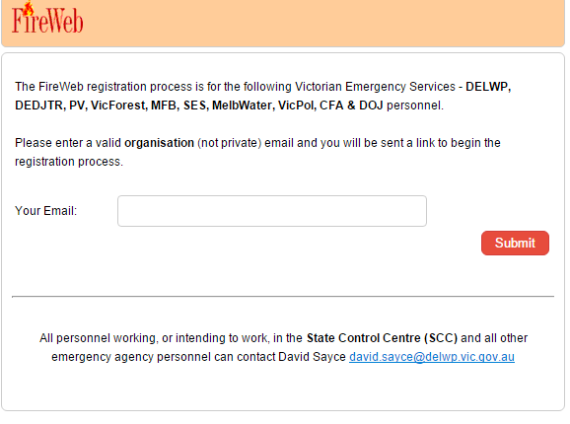

Remember to advise that you need Resources Management access level

Using SRRS – An Overview
The welcome screen is known as the SRRS Home Page.

From the Home Page, you can:
- Read ‘What’s New?’ read the text on the Home Page by scrolling down the screen
- Access the SRRS User Guide
- very bottom of the Home page

Once you have accessed SRRS, click the Login button

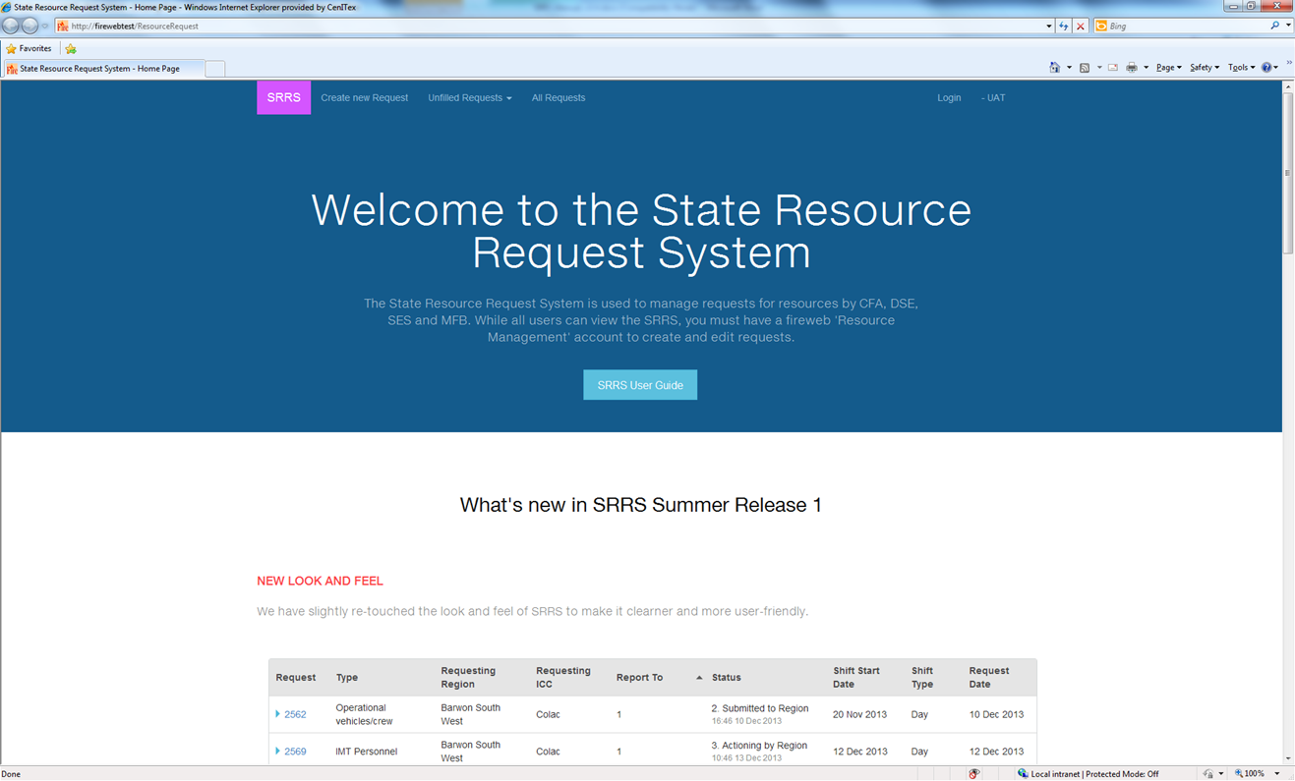

Then enter your Fireweb User name and Password

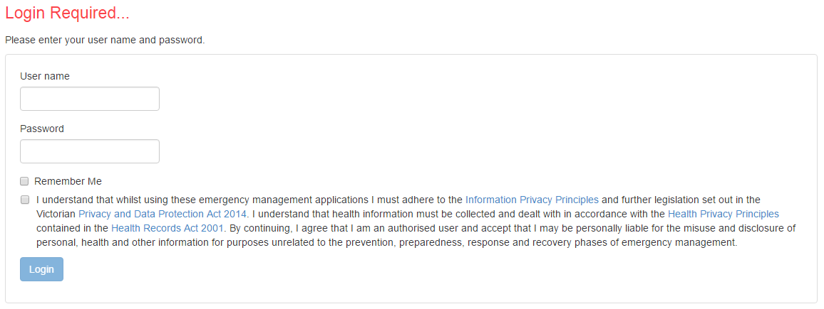
You must acknowledge the privacy statements before the login button will highlight for you to select
it.

- Start working on a request or look at existing requests by selecting one of the following options in the main menu ribbon at the top of the screen.

  - New Request
  - Display all
  - Display (unfilled or filled)
  - Look at a
  - Run reports tracking resource requests

Request Lists – Search for Unfilled Requests
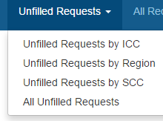

Unfilled Requests are all Requests that have not been Closed or Cancelled, even if they have been filled with resources and movement orders created.

Selecting the appropriate option will present filters to narrow your search.
- Search Unfilled Requests by ICC 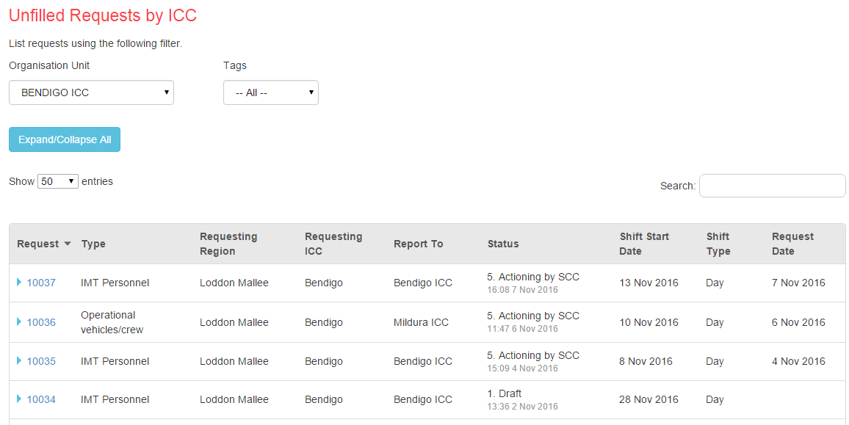
- Search Unfilled Requests by Region.
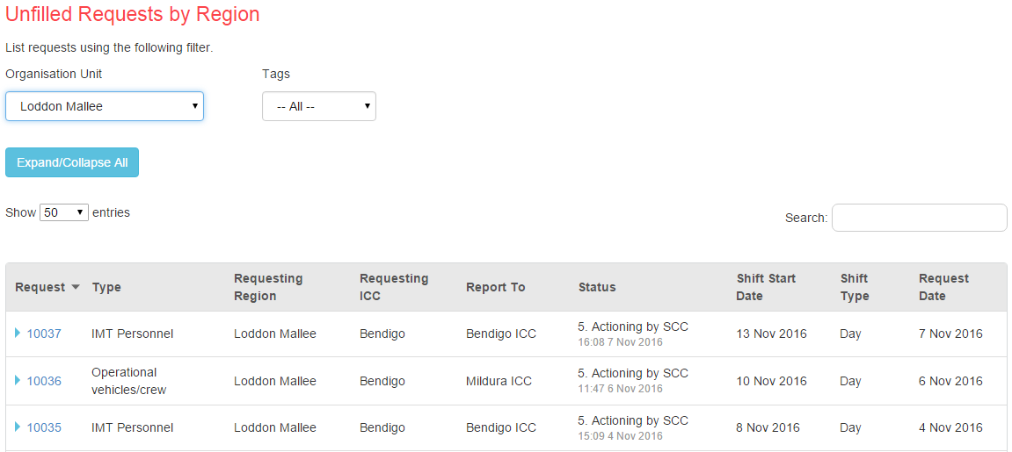

- Search Unfilled Requests by SCC
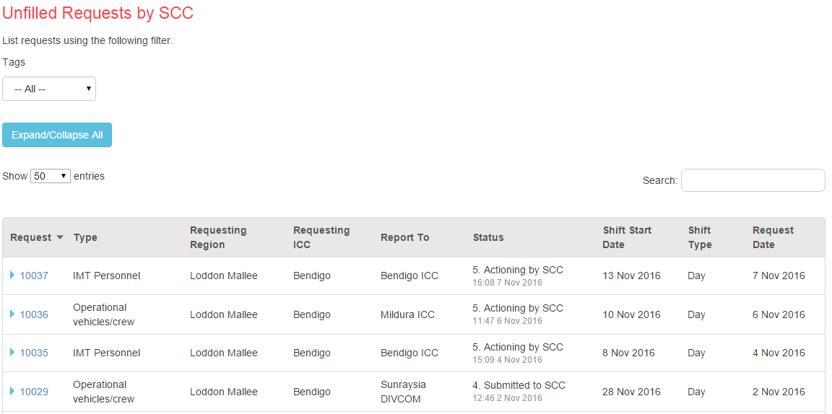

- Search All Unfilled Requests
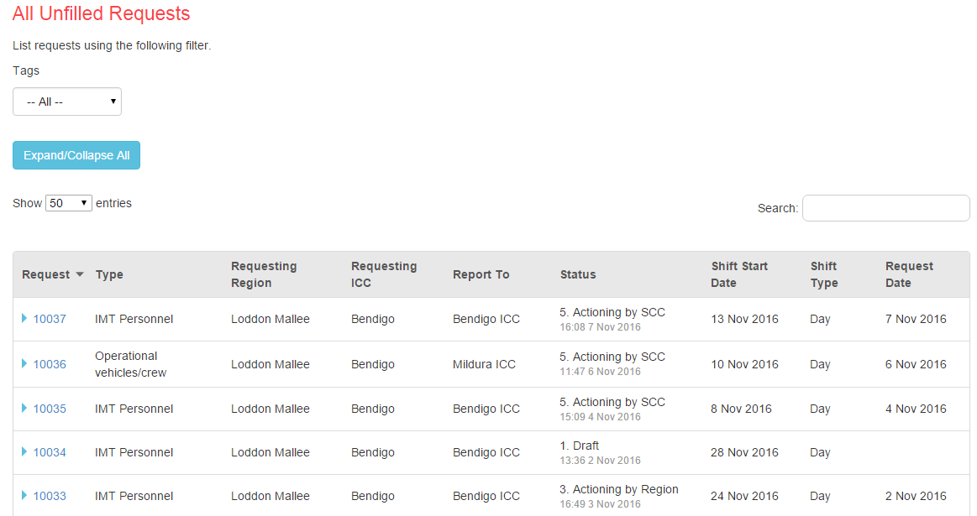

On entering your search criteria, matching requests will list from most recent to oldest.

All searches support these actions:
- Click Expand/Collapse All button to view more, or less, detail on each request
- Change the number of entries displayed on the screen (default is 50)
- Click the request number (e.g. 10037) to work on that request
- Use the search box (top right of screen) to search on visible text in the list
- Sort the list by clicking any column headings- e.g.:
  - Click on to sort by Request type
  - Click on 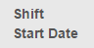 to sort most recent to oldest shift start dates
- Clicking the page buttons (bottom of screen) to move through the list of requests 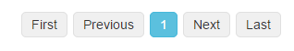
- Request Status
  - The request status is the progress of the request
The Status of the request controls the actions you can do.
The person or role responsible for performing those actions is governed by Business Rules and the Command and Control structure.
If you are unsure of who is responsible for taking action on a request, please refer to JSOP 3.09 – Resource Management.

If you have incorrectly escalated a request (e.g. from RCC to SCC) you can still action the request at RCC level - just make sure you contact the SCC and make a note in the call notes section to this effect.

Requests can move through seven statuses- refer to Appendix 1 for detailed explanation.

To return to the home page at any time, click the (top left of the page).

Creating and Fulfilling Resource Requests and Generating Movement Orders

Overview
Resource Requests have 3 main forms/sections, with the following components:

Requests Form
Request Details | Basic details about the request - requesting ICC and Region; incident name; shift details (e.g. when the resource is required at the incident)
Resource Types (also known as Request Items) | You add Resource Types so suppliers know what types of resources you need. The resource types are based on a list contained in Fireweb.  Once added to a request and submitted to the Region, the Resource Types are listed in the Request Items section. In this section, resource officers can identify specific individuals or crews to fulfil the request item and the supplying agency and location (District or Region).
Fulfilment Form
Call Details | Used to record details of conversations you have had with Regional Controllers, Agency Commanders, Duty Officers or other Resource Officers when you’re determining who can fulfil that request
Attachments | Used to attach additional information to the request – e.g. the names of the individuals within the crew that will be sent to the incident, or info regarding the terrain the vehicle must be capable of being driven in.
Movement Order Form
 | Used for the creation and publishing of separate movement orders for each location that will supply resources to the requested location.

Step 1 - Create a New Resource Request -

Requesting Resources Officer Completes. (ICC,RCC,SCC that requires the resource)
The Requesting IMT Resource Officer logs into SRRS then clicks

A form opens the components of which are explained below.
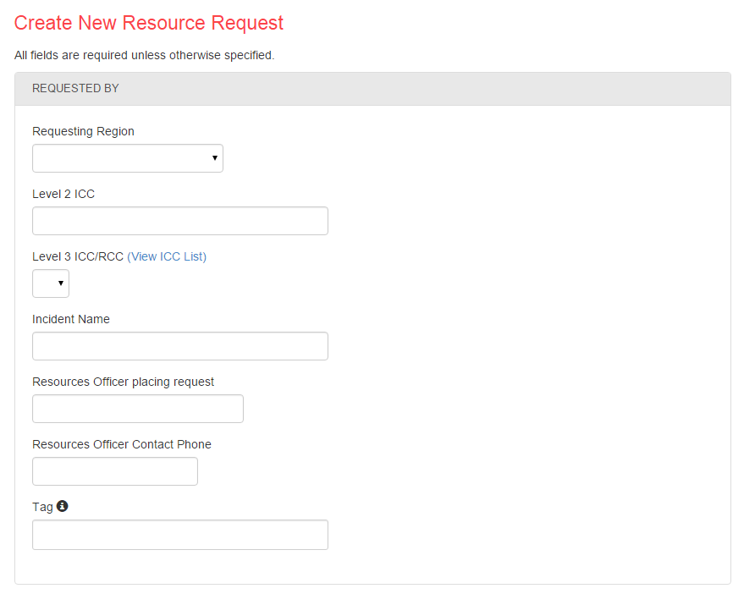

REQUESTED BY
Requesting Region | Select the Region that requires the resources from the drop down list.
Level 2 ICC | Mandatory Field - Ability to add Level 2 ICC Location. This is a free text field, type in the relevant ICC  Use N/A if not applicable
Level 3 ICC/RCC | Defaults to all ICCs within your selected Requesting Region.  Select the ICC from the drop down list (includes all Victorian Level 3 and SES ICCs).
Incident Name | Start typing the name of the incident.  If known to SRRS, pick from the list presented.  If no list is presented, type the incident’s name, ensuring it matches the name signed-off by the IC.
Resources Officer placing request | Start typing the name - select the requestor from the dropdown list.
Resources Officer Contact Phone | Ensure you record the phone number of the ICC you are working in, or the desk phone for the Resources Unit.  Do not use your mobile number ~ or you will receive calls after your deployment has ended when there are queries.
Tag | Optional field- Used to classify the request ~ they enable additional searching capability in the Unfilled Requests and All Requests sections.  Currently there are only two Tag options- Planned Burning or IILU.

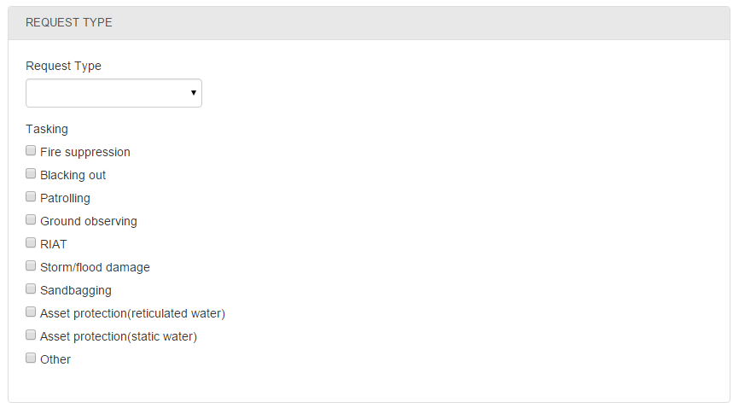

REQUEST TYPE
Request Type | Select an option from the dropdown list. Options are:  IMT Personnel  Operational Vehicles / crew  Specialist / Other  Selecting IMT will allow you to auto-populate a full Level 3 IMT when adding resource types.
Tasking | Check (‘click’) the relevant boxes.  This section is used for SRRS reports.

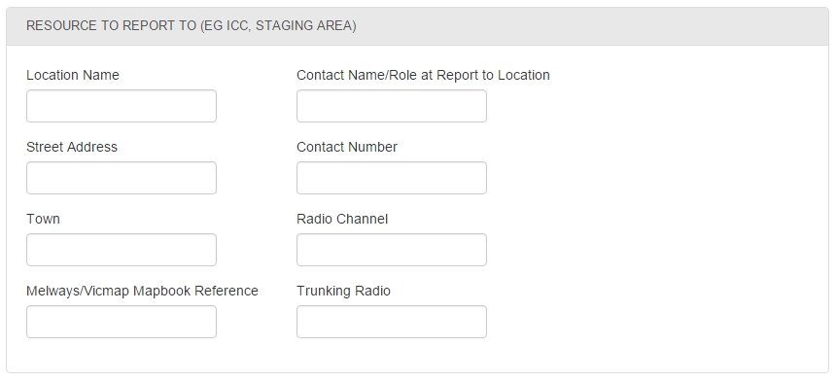
RESOURCES TO REPORT TO (E.G. ICC, STAGING AREA)
These fields identify where the requested resources will be deployed to, and who they can contact when they arrive.
The boxes above are all free text, but you must complete the Location Name, Street Address and Town to progress the request ~ all other fields are optional.
Location Name | Could be the ICC, RCC, SCC, Staging Area, Base Camp, where ever the resource is being deployed to
Street Address | Actual address where the resource is to report to
Town | Actual town where the resource is to report to
Melways/Vicmap Mapbook Reference | e.g. 43 K2 – for the deployed resources to find that location, if required
Contact Name/Role at Report to Location | Who they’re reporting to on arrival
Contact Number | The contact number of the person they’ll report to, on arrival
Radio Channel/Trunk Number | Incident or communications channel the deployed resources can use to contact at the incident, if required e.g.. ICC Operations Trunk No
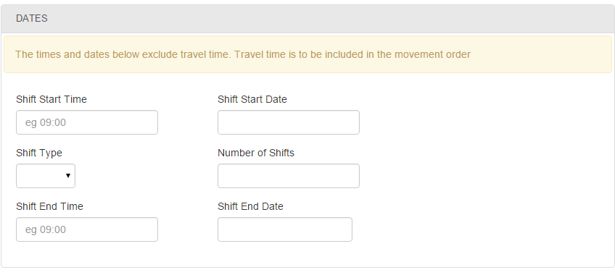
DATES
This section of the form is specifically relates to the deployment to the incident

DO NOT include Travel days in this section (If applicable) Travel is to be included on completion of the MOVEMENT ORDER either side of these dates!

Shift Start Time | Format is in 24 hour clock – e.g. 19:00, not 7:00 PM. Actual Shift Start Time
Shift Start Date | Date of the first deployment shift. Actual Shift Start Date Do NOT include Travel
Shift Type | Dropdown list options are Day, Night or Swing
Number of shifts | The number of shifts selected will automatically populate the Shift End Date.  If left blank, SRRS will auto-fill this field, based on your Shift Start/End Date.
Shift end time | The Shift end time in 24-hr format – e.g. 20:00, not 8:00 PM.
Shift end date | Date of the last deployment Shift – will auto-fill based on your Number of Shifts you enter. Do NOT include Travel

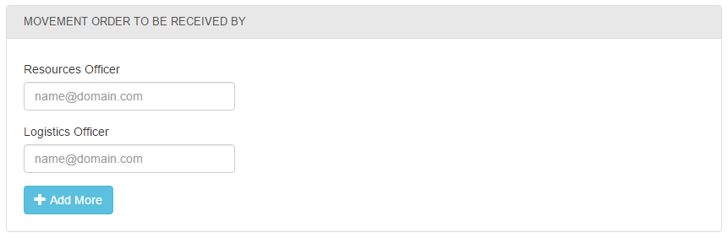
MOVEMENT ORDER TO BE RECEIVED BY
Resources Officer | Auto-populated based on the receiving location Level 3 ICC, if incorrect then use the option
Logistics Officer | Auto-populated based on the receiving location Level 3 ICC, if incorrect then use the option
 | Click to add more email addresses
Email | Free text email field to add more email addresses.

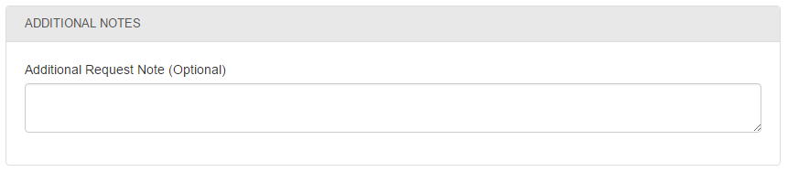

ADDITIONAL NOTES
Additional Request Note (Optional) | Free text appears under Request Comment in the Request Summary  You can include any additional information you want to in the request.
When finished creating your request, you can choose to:
 | Continue working on your request later …
 | Add the types of resources you need…
Print Request | Opens request in Adobe Reader (pdf format)
Cancel request | Prompts acknowledgement that the appropriate people have been advised and comment field (optional – however encouraged)
 | Cancel your draft request entirely

Step 2 – Add Resources to Request - Requesting Resources Officer Completes

When choosing Add Resources, this screen displays:

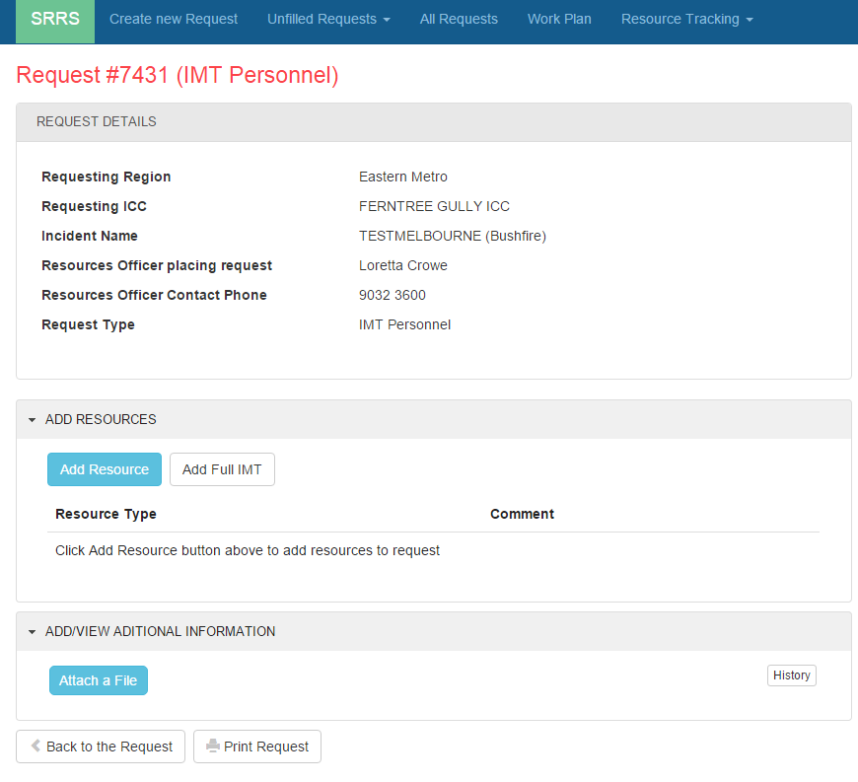
Click

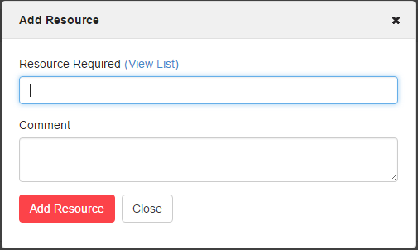

While you can type into the Resources Required box, you should always click on the View List

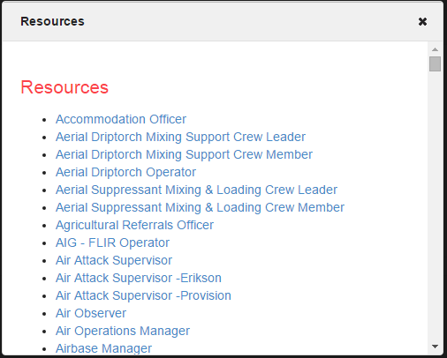

Select the resource/s required from list as above. This ensures consistent naming conventions.

Add a comment to include any specific requirements of the role e.g. mentoring opportunity or must be a specific agency

You can add multiple resources to each request, each of which can be edited or deleted.

When you have finished adding resources, you can:

- Go or
- or
- which will commence the fulfillment process
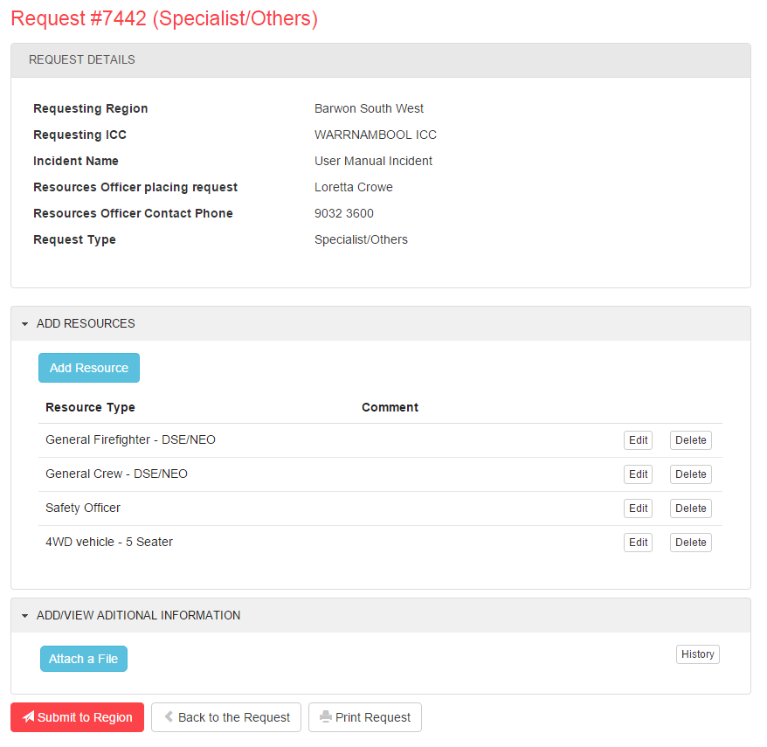

An example of a printed request is shown in the attached pdf.

Clicking presents the following prompt

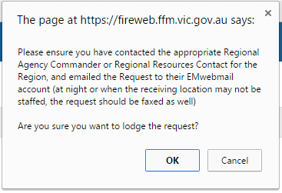

Clicking 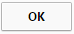 progresses the request to Lodged!

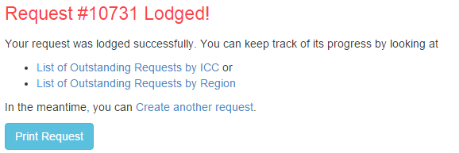

Request Progress “2. Submitted to Region”

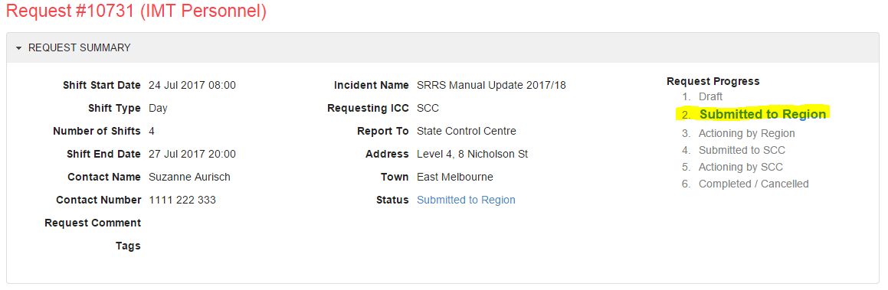

Once the request has been lodged – the requesting Resources Officer must contact the Regional Controller (or delegate this could be the Rostered Resources Officer or RAC Specific to the Event) to advise a new request has been lodged to the Region to be actioned.

COACHING AND MENTORING
Currently there is no area within the SRRS to specifically identify if a mentee can be added to the request.

A number of key roles have been identified by the Resources Capability Group as key roles that if the sending Region has the capability and capacity to provide they can add to the deployment to be mentored.

The roles identified are:
- Incident Controller
- Operations Officer
- Safety Officer
- Planning Officer
- Resources Officer
- Situation Officer
- Public Information Officer
- Warnings and Advice Officer
- Media Officer
- Logistics Officer

Make sure you have discussed the additional numbers with the Incident Controller and Logistics Officer, prior to finalising the request to ensure that there is capacity in the ICC accommodation (both office and hotel) to accommodate the extra numbers.

When you are requesting IMT roles either as one individual request or a range of IMT positions include an additional resource line for a member, or lesser level of the roles listed above.

In the comments field advise that this is a mentoring opportunity if the sending region is able to provide.

Adding the additional line will enable the details of the person to be added to the movement order, and allow logistics to correctly account for the number of people travelling and requiring accommodation and meals.

Step 3 - Filling the Request- (Supplying Regions responsibility to complete)
The Resources Officer (or similar role DO, RAC or delegate), upon the requestors notification of a request being lodged and submitted to Region.

- Click
- Select Unfilled Requests by Region
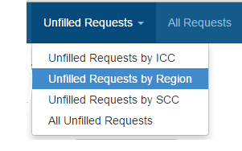
- Select the relevant Region
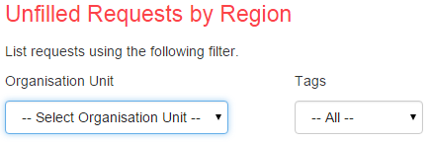
- Select the relevant request to expand to view the complete form.
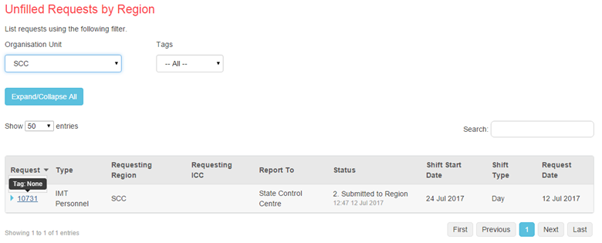

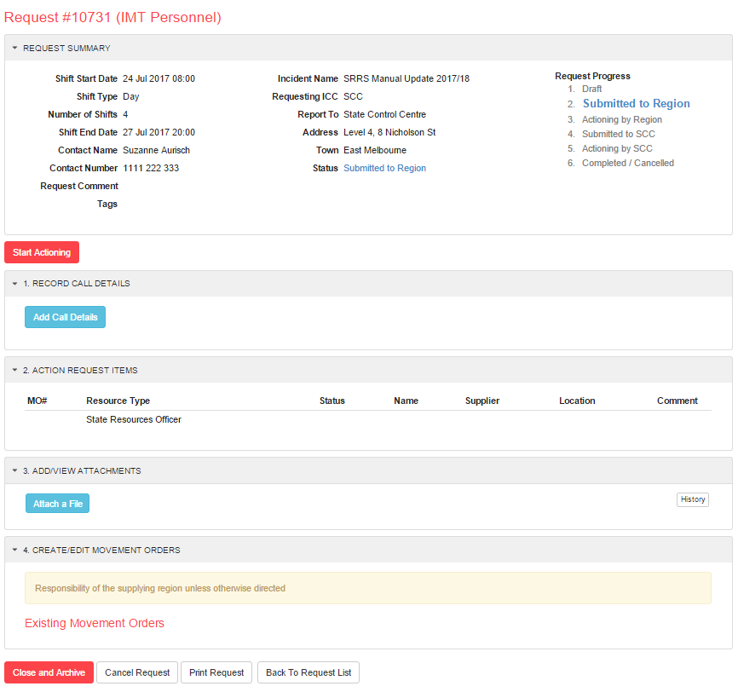

This form contains five sections:
Request Summary | Summarised view (Snapshot) of the Request/deployment Information
Record Call Details | A record of all calls pertinent to sourcing resources for the request, including to Resources Officer. Regional Controller and Agency Commander and/or delegate.
Action Request Items | Identifies the resource/s type being requested – e.g. individual role, crew or vehicles
Add/View Attachments | Ability to attached information specific to the request, that may assist with resource allocation and/or movement order – e.g. IRIS 691 report
Create/Edit Movement Orders | The final step – resource deployment requirements e.g. mode of transport, accommodation requirements etc.
Clicking the presents the prompt below

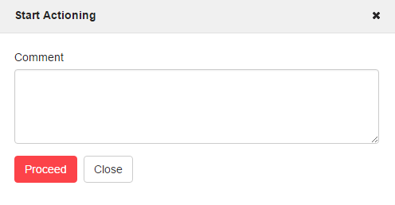
Record who authorised the request to be actioned (Resources Officer who advised it had been lodged, or can be Incident Controller or Planning Officer) the click 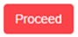

The request will be set to Status to “3. Actioning by Region”.

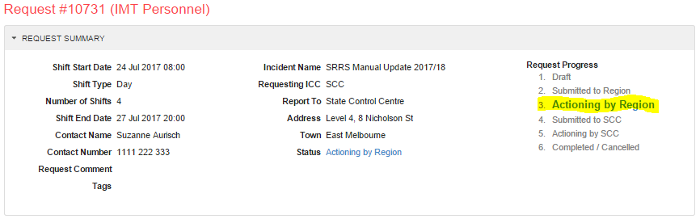

Note -
The 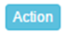 will not appear in the 2. Action Requests section unless you the request.

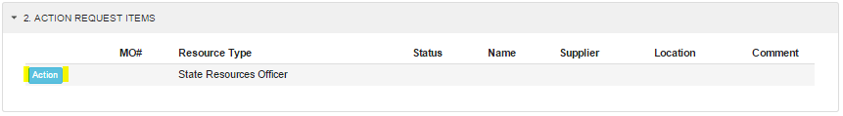

- Record Call Details
All conversations (telephone and/or verbal conversation) are to be recorded against the resource request, and can be added at any time, even after the request is closed or cancelled.

Click the 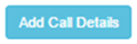button and complete the details
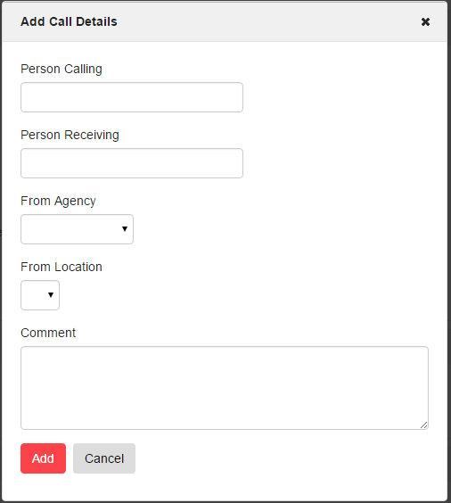

Add Call Details
Person Calling | Person who initiated the conversation or telephone call.
Person Receiving | Person who received the telephone call or who was part of the verbal conversation.
From Agency | Agency the person you’re contacting is employed by.
From Location | Location the person you’re contacting is from. Depending on Agency, it could be District, Region or SCC
Comment | A true recount of the telephone call or verbal conversation.

Clicking will date/time stamp each record which cannot be deleted or edited.
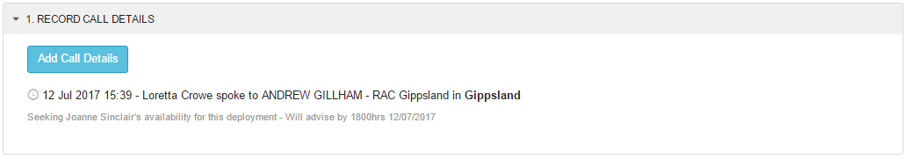

Note – You can record comments in two section on the Request Summary Form:
1. Call Details (if the comment relates to the request)
2. Action Request Items (if the comment relates to the resource required (Role) e.g. agency specific)

- Action Request Items
When a Resource Type, e.g. a particular individual, crew/team or vehicle, is identified as being available and suitable to fulfill the request item, click on the adjacent 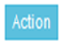 button.
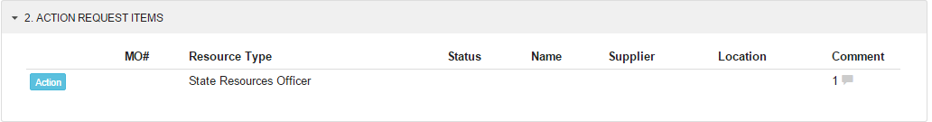

The Status box has two options at the Actioning by Region level
- Filled
- No Longer Required
This will open an Amend Resource Request dialog where you can
Filled  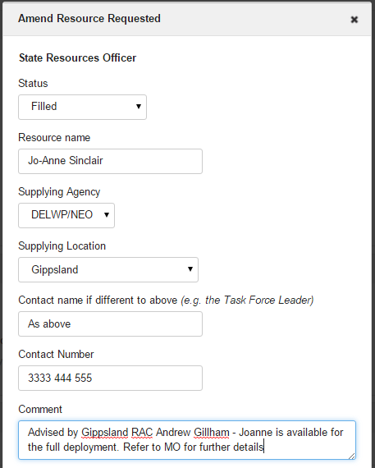 | Status: Filled  On selection the Amend Resource Requested dialog box will expand for completion.  Resource name: Start typing the name of the individual, crew or vehicle. If they have been deployed before in SRRS, their name will show as an option. NB: Ensure you spell people’s names correctly. For a crew/strike team, enter the name of the crew or strike team and ensure you attach the individual member names as an attachment, or in the Crew Details section.  Supplying Agency: Options are:  Joint  CFA  DELWP/NEO  SESVic  MFB  Your choice of Supplying Agency controls offerings in the Supplying Location: Select Region or District from list  Contact Name: This field is required to be completed for Operational Crew Resource Types (Taskforce/Strike Team and Crew Leader). IMT Base, Primary and Core (Incident Controller)  Contact Number: This field MUST be completed.  If the request is for an individual record their contact number.  If the request is for Crew or Taskforce or Strike team, then record the contact number of the Crew/Team Leader.  This number is recorded on the movement order, and is used to contact the person direct, if they are late arriving or details of the deployment change.  If personnel are driving to or from deployment, then it is essential they are able to be contacted direct while in transit.  Comment: Any additional information that will help with the MO

No Longer Required  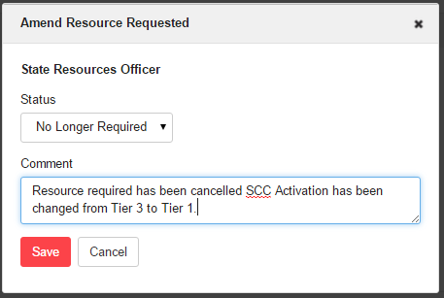 | Statustatus: No Longer Required  Comcomment: Justification/reason and/or brief explanation
Unable to be filled is a third option but this is only available when the request progress is 5. Actioning by the SCC)

Complete the Request/Fulfilment Process – Regional Control Centre
Completion means all items requested on the movement order are recorded as either
Status: Filled or Status: No Longer Required.

The Region should escalate the request to the State Control Centre for sourcing if it is unable to fill one or more of the items on the request. It can do this by clicking 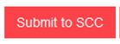

A warning message (below) will appear:
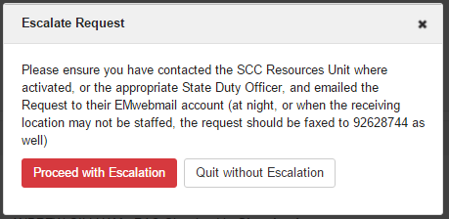
This will set the Request Progress to “4. Submitted to SCC”.
Click on the Proceed with Escalation button to continue.

Record who authorised the request to be actioned (Resources Officer who advised it had been escalated or can be Regional Controller, Regional Agency Commander or their delegate) then click

This will set the Request Progress to “5. Actioning by SCC”.
Complete the Request/Fulfillment Process – State Control Centre
The SCC will attempt to identify available and capable resources from other Regions, Interstate or International agencies to fulfill the resource requirement.

It is important that the RCC remain in contact with the SCC to ensure that the requested resource is still required. Ensure the command and control structure is adhered to, as set out in JSOP 3.09.

Clicking the presents the prompt below

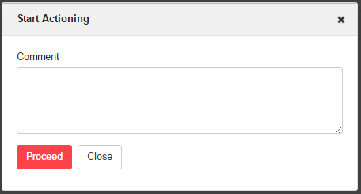

If the SCC is able to source a resource, it will set
Status: Filled and complete the details. Otherwise it will set the Status: Unable to be Filled.

The SCC will then request the Supplying Location to complete the movement order details.

- Add/View Attachments
Add attachments to support the requested Resource Type e.g Maps, Situation Reports or IRIS 691 reports etc, you would like sent out (emailed) with the Movement Order.

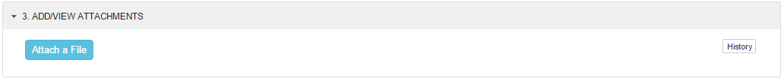

- Create/Edit Movement Orders
Complete the Movement Order Form - (to be completed by the supplying Region or District)
The final step in the process is to capture the Movement Order details.

Logistical details that inform the supplying ICC/RCC/SCC location the Resource is returning to:

- When they are returning
- How they are returning
- Assists Fatigue Management
The Movement Orders are predominantly logistical details that inform the requesting/receiving ICC/RCC/SCC location the Resource is reporting to:

- Who is coming
- When they are coming
- What accommodation they need
- What transportation they need
- Any dietary requirements
- Assists Fatigue Management
This data must be completed by the Supplying location particularly contact numbers and dietary, travel and accommodation requirements.

When a number of Regions/Districts/Agencies fill one request (for example half a TF from Port Phillip and half from Gippsland or 10 IMT Roles 5 filled by Grampians CFA and 5 filled by Grampians FFMVic) Individual Movement Orders are created for each supplying Agency/Region/District who have agreed to supply resources to the requesting location. Therefore, one Request can have multiple Movement Orders.

Further, each change or edit made to a movement order will generate a new version number with a comment.

Movement Orders numbers align with Request Numbers, with an alpha suffix for each movement order linked to the request (e.g. 3233-A, 3233-B).

Completing the movement order details will publish that movement order. i.e. create a PDF which can then be distributed by the RCC or SCC via EM Webmail to the receiving and supplying locations.

The following sections describe how to complete the Movement Order form.

Task 1 – Generate Movement Order
- Click on “4. Generate/Edit Movement Orders”;
- Select the relevant supplying location
- Click on Generate button
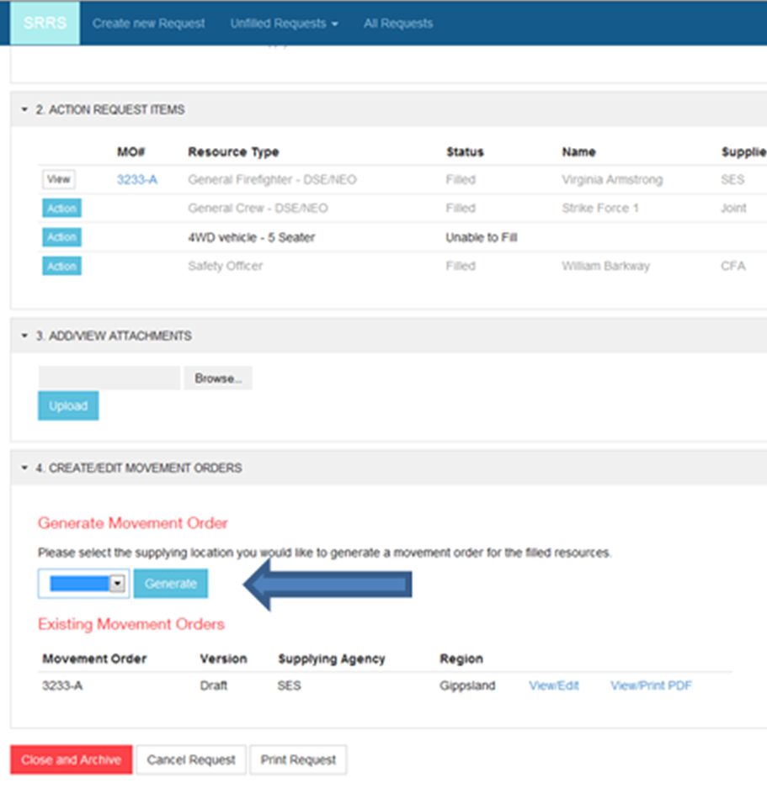
This will open the movement order form and allow you to complete the sections

Information relating to the resources being deployed on this movement order, including dietary and deployment constraints.

This section has different components for Individual Resources (e.g. Planning Officer level 2) and Crew Resources (e.g. Strike Team or Task force).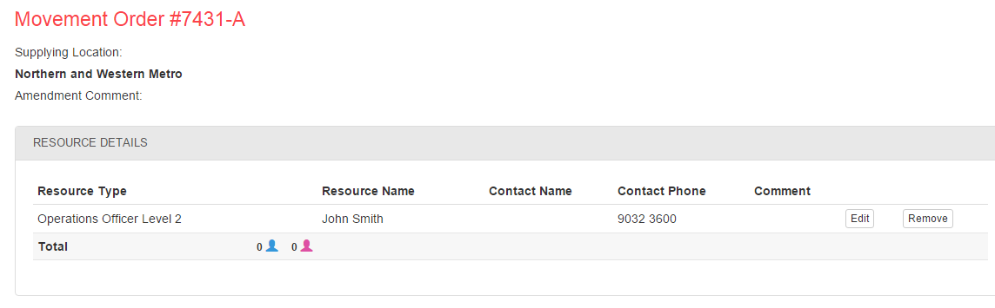
Click Edit button (see above) results in the following: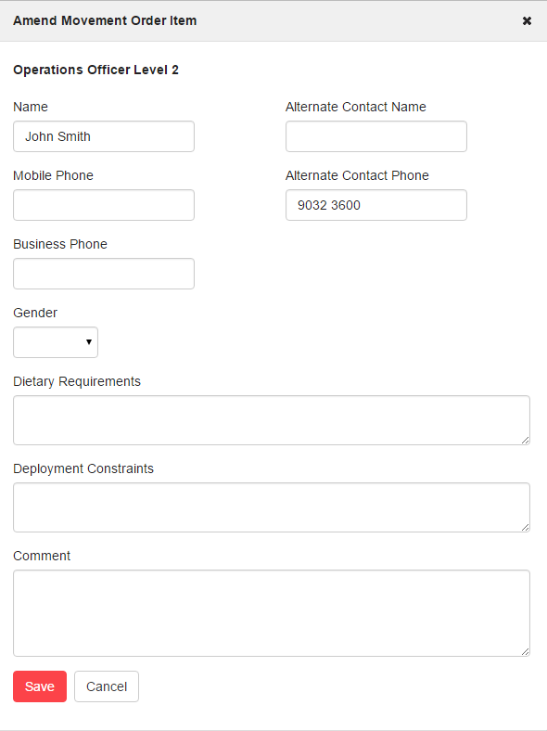

RESOURCE DETAILS
Name | Auto-populated form the previous screen.  Only requires data entry if information is incorrect.
Mobile Phone | Auto-populated from Fireweb (if recorded in FireWeb).- confirm it is current and correct  Otherwise, enter then number if known.
Business Phone | Auto-populated from Fireweb (if recorded in FireWeb).  Otherwise, not required.
Gender | Auto-populated from Fireweb (if recorded in FireWeb).  Otherwise, select gender
Alternate Contact Name | Only to be used if someone other than the named resource is to be contacted.
Alternate Contact Number | Defaults to the contact number entered in the previous screen.
Dietary Requirements | Free text field: enter if known.
Deployment Constraints | Free text field: enter if known.
Comment | Any extra information you want to display on the Movement Order per resource.

If you selected Resource Type: Crew clicking the Edit button will let you list the names of all members of every crew member via the additional Crew Members tab.

You have two options.
- If you choose Details of crew members is known (excluding Crew Leader), then enter the name and gender of each crew member.

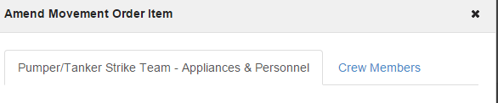

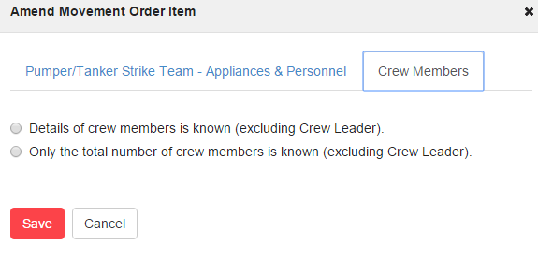

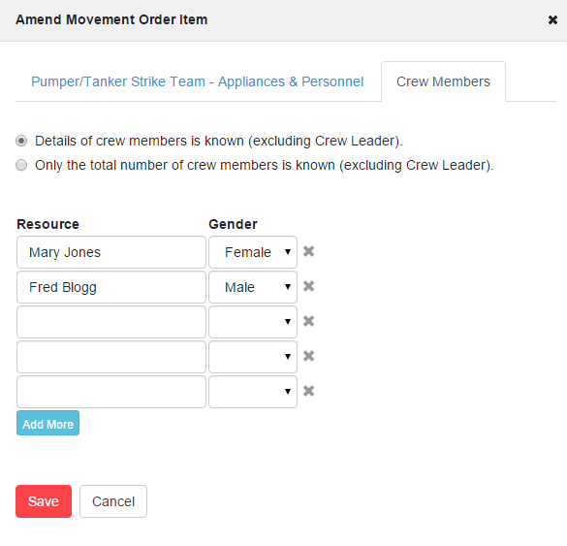
- If you choose Only the total number of crew members is known (excluding Crew Leader), then enter the count and gender split.

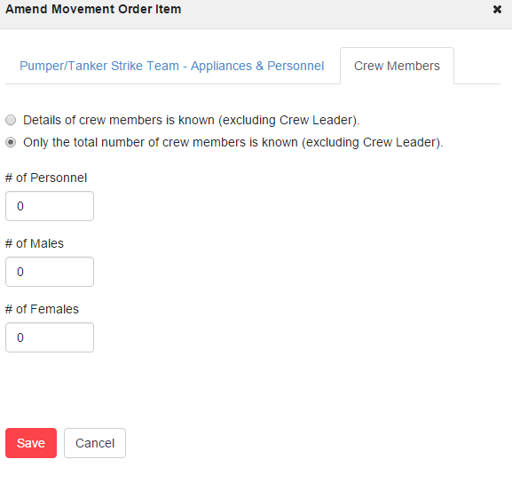

Deployment/Shift Details
Information relating to shift time and dates
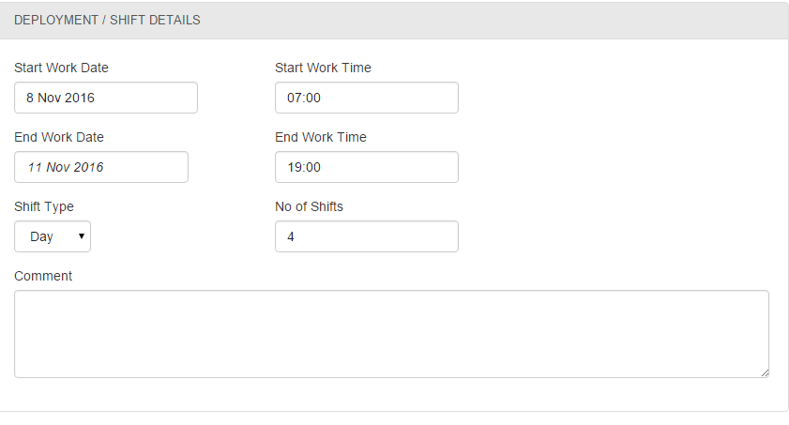

DEPLOYMENT / SHIFT DETAILS
Start Work Date  Start Work Time  End Work Date  End Work Time | Pre-populated form the information in the request
Shift Type | Pre-populated form the information in the request
Number of shifts | Pre-populated form the information in the request
Comment | Any additional information to assist the deployment of resources

Note- if the deployment details are unable to be filled in entirety as requested notify the requestor, via a phone call, of the changes.

Travel Details
Information on mobilisation and demobilisation dates, where and to whom the resources should report to.

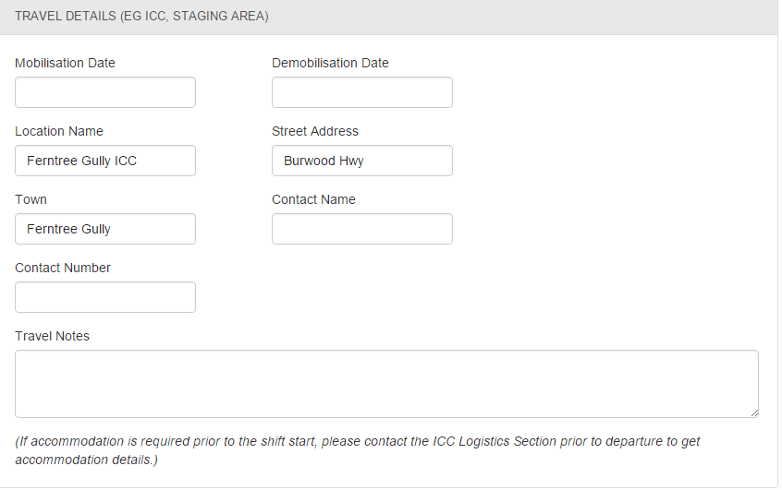

TRAVEL DETAILS (EG ICC, STAGING AREA)
Mobilisation Date | The date of travel to the deployment location.  Depending on where the incident is and the start time of the shift, this could be the day before the shift is due to start, or could be the day of the shift.  Ensure this is correct - as Logistics use that date to determine accommodation and catering requirements.
Demobilisation Date | The date of travel home from the deployment location.  Depending on where the incident is and the finishing time of the shift, this could be the day after the shift is finished, or could be the day of the shift.  Ensure this is correct - as Logistics use that date to determine accommodation and catering requirements.
Location Name  Street Address  Town | Pre-populated from information entered previously.
Travel Notes | Used to explain exactly how the resource is travelling to and from the incident, and confirming the arrival and departure date

Resource Details (NOT TO BE USED FOR NEW REQUESTS AND MOVEMENT ORDERS)
This section will eventually be phased out.

It has been retained so users can view historic movement orders that utilized this section.

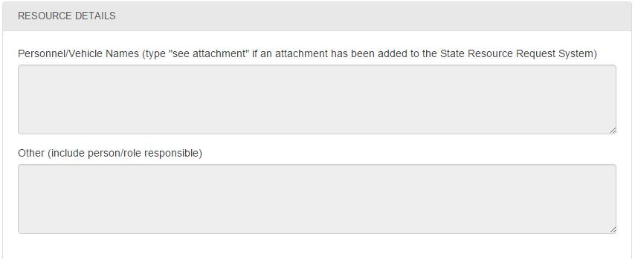

Accommodation / Dietary Requirements
Information on the accommodation requirements for the resources being deployed (this is very important for the logistics staff at the receiving location).

The Dietary Requirements section should not be used. It has been retained for historical purposes only. Dietary requirements should be captured under Resource Details against each named resource.

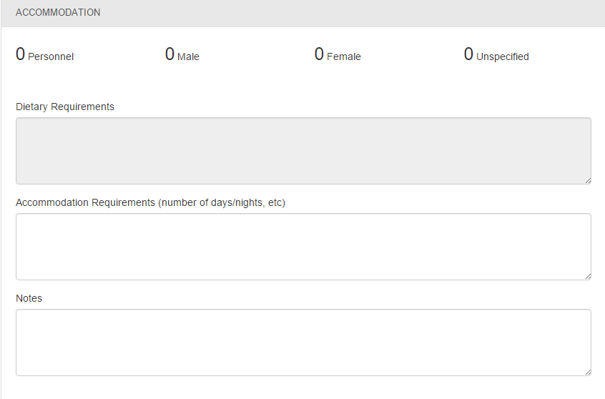

ACCOMMODATION
Detail the number of nights (days) that accommodation is required.
Ensure you include details on the expected arrival and departure time for the resource.
Notes | Free text field.

Safety
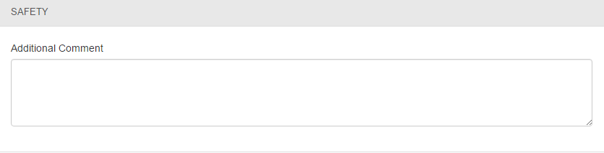

SAFETY
Additional Comment | Any specific safety instructions that the Incident Controller wants passed to the resources being deployed.

Add/View Attachments
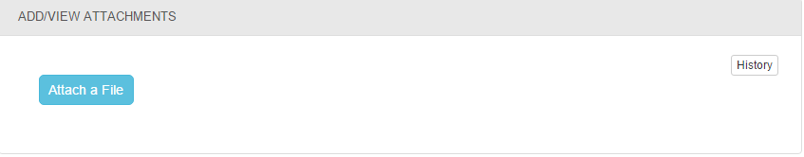

ADD/VIEW ATTACHMENTS
Attach a File | Add attachments that you would like sent out (emailed) with the Movement Order.

Movement Order Summary
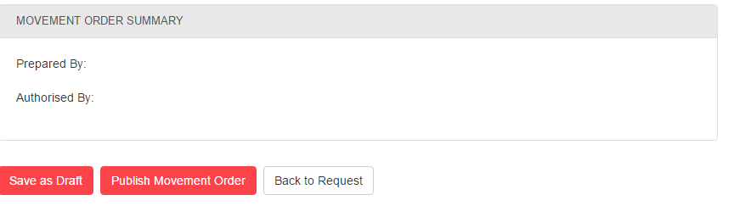

Task 2 – Publish Movement Order and Distribute
After completing data entry, you can:
- Save as Draft or
- Publish Movement Order entering prepared by and authorised by detail
If all details are complete, you can publish the Movement Order which can be viewed or published as a PDF. Publishing also creates a link against the Action item Request.

Once you select Publish Movement Order a box will pop up asking who prepared and who authorised the creation of the Movement Order.

See Appendix 2 for an example Movement Order

Task 3 – Disseminate Movement Order
The distribution of Movement Order documents is the responsibility of the RCC or SCC (to whom the request was escalated).

There are two options:-

- Click View/Print PDF against the relevant movement order (must not be Status: Draft). And save and email to the relevant personnel
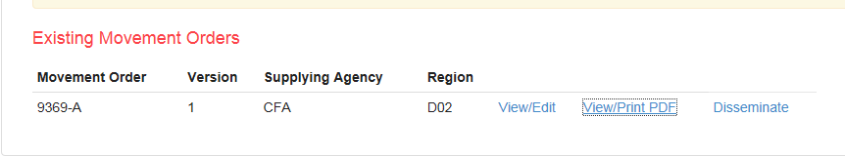

This will open the movement order as a PDF.
Save the movement order in the appropriate folder for the RCC or SCC.

- Disseminate the movement order direct from SRRS to relevant personnel

Once you select Disseminate the following box will pop up
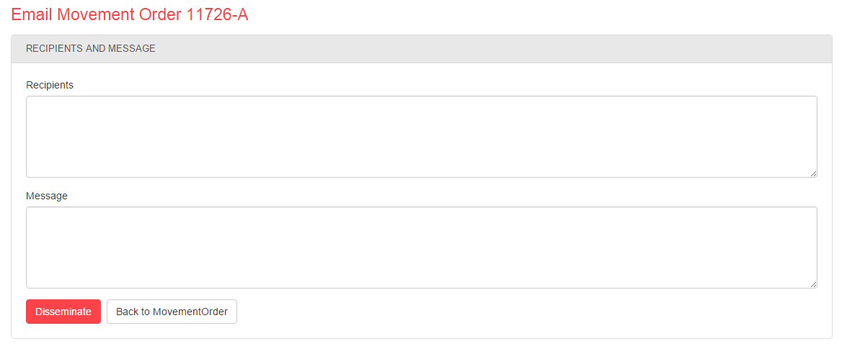

Enter the email addresses of all locations/personnel that you need to send the movement order to.
Create the email address and then select enter, so the next email address is put onto the next line. Repeat this for as many lines as you need to.
Note- the Disseminate box does not allow the same email to be entered twice, nor does it like the email addresses to be separate by a comma (,) need to be a separate line

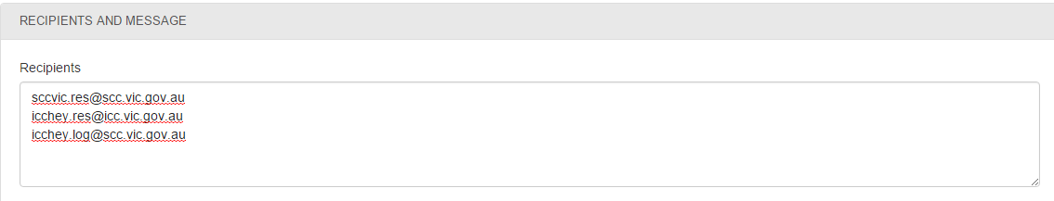
In the message section type in any message you need to add. Add your name and role in this box as well, so personnel receiving email know who has sent it.

The select Disseminate button

Next a box will pop up to show that the message has been sent and where it was sent to. Make sure you include your Unit’s email address so that you can see that the message has been sent

Note that the email that is received from the disseminate option is a DO NOT REPLY email, so you cannot reply, if you need further information you need to contact the sender via the information in the movement order of original request.

If you want to resend the Movement Order, or find that you need to send to further email addresses, just re-follow the process above

The Movement Order MUST be sent to all relevant personnel regardless of which option above you chose
- The receiving ICC Resource EM webmail account
- The receiving ICC Logistics EM webmail account
- The supplying location (Regional Controller, Regional Duty Officer, Regional Agency Commander, or requesting officer organising the dispatch)
- Where the request is obtained by the SES or MFB State Duty Officers also include the relevant State Duty Officer email
- The EM webmail account where the request was escalated to (eg SCC/RCC)
If you need determining the email addresses refer to the EM Webmail instructions in EM COP:-
EM COP/Desktop/Training 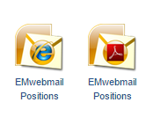

Task 4 – Edit Movement Order (if required)
To edit the Movement Order
- search and find your Request ID,
- click the Create/Edit Movement Order section
- Click Edit Movement Order.
For Published Movement Orders
- changes can only be made by way of a Note
- you cannot edit the body of the movement order after publishing.
If in doubt keep the movement order in Status: Draft, until finalised.

Step 4 – Closing and Cancelling Requests
Cancelling
- Requests can be cancelled at any time if the required resources are no longer required.
- Do not cancel a request from another location until you have spoken to the requesting location
Closing
- Requests should only be closed once the required resources arrive at the incident/location.
- Do not close a request from another location until you have spoken to the requesting location
Who is responsible for the closing/cancelling?
- It is the responsibility of the requesting (creating) location to cancel or close the request.
Once Closed or Cancelled you will only be able to see information via the All Requests section

Reports Available in SRRS
Work plan
The Work Plan section:-
- lists what requests are being actioned and by whom at SCC and RCC level only
- lets the Resources Officer place those requests being actioned into a “bucket” and then assign them to personnel in the unit to action.
- eliminates the need to trawl through the many pages of requests to find a request that has been carried over from a previous shift.
- provides transparency to the actions and priorities driving resource requests at RCC and SCC level.
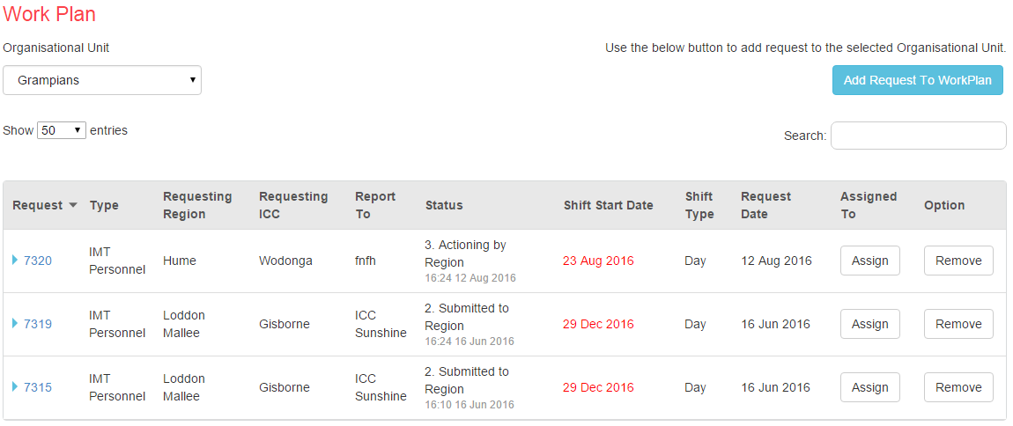
Resource Tracking
You can create a 7-day View and a 28 day view to track resource requests in a calendar fashion/view.

7 Day View
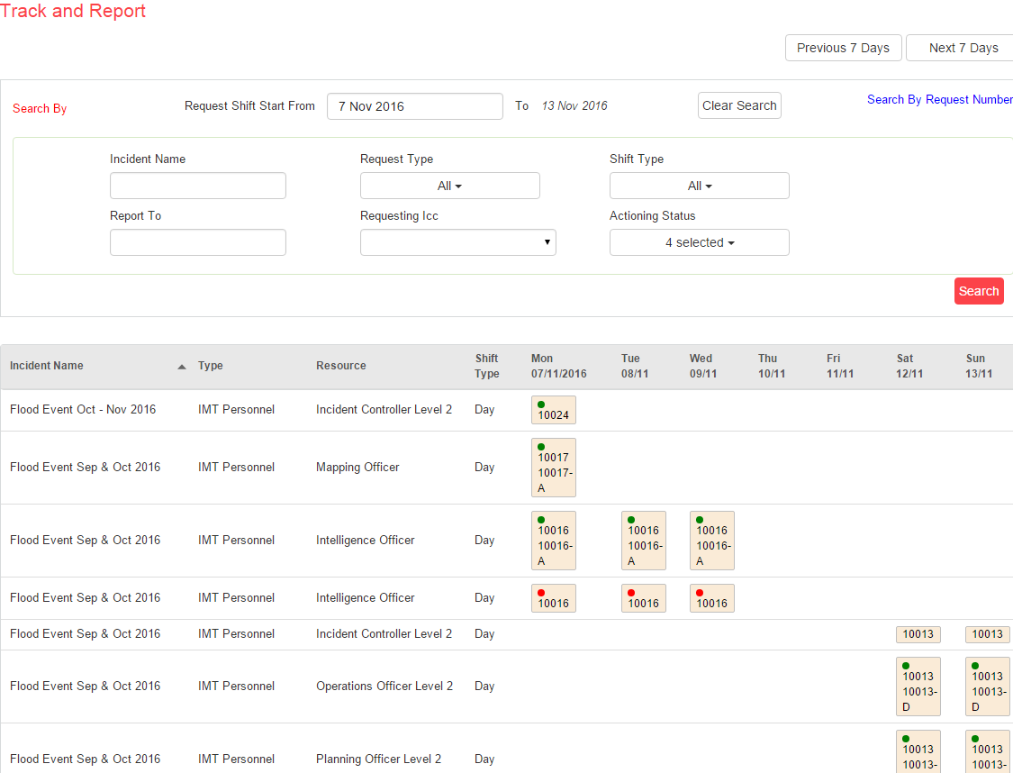

28 Day View
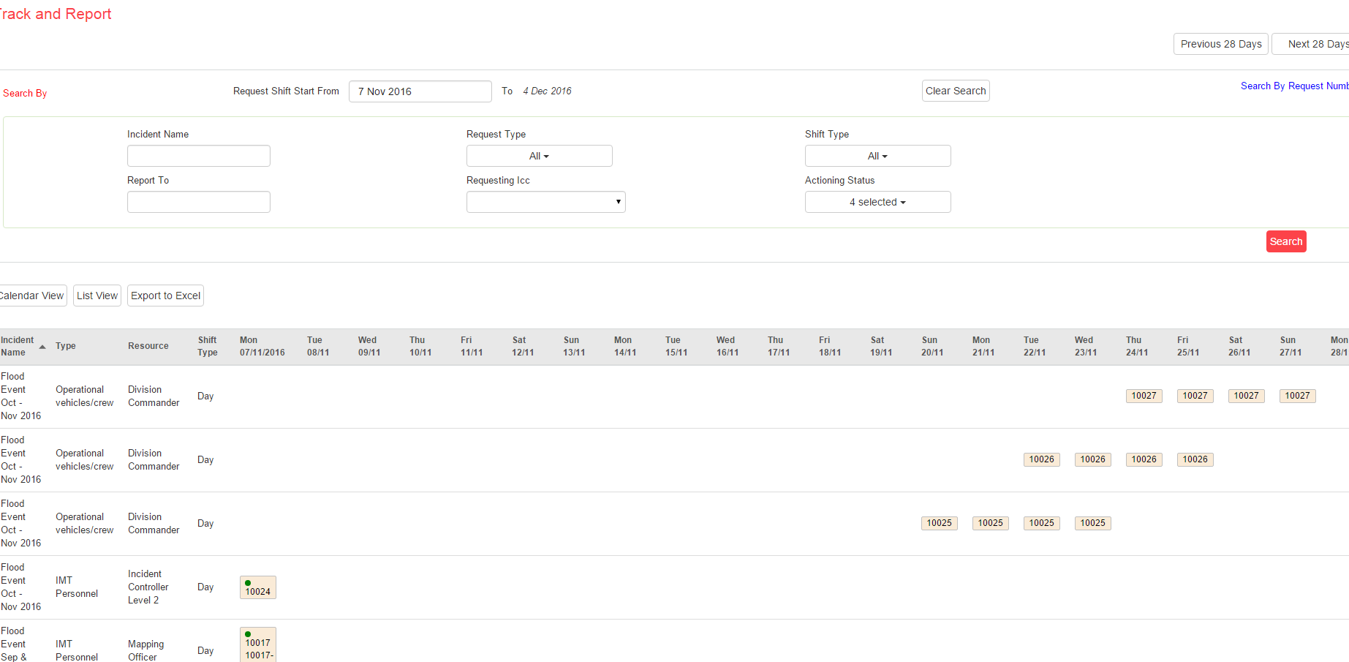

What it is?
The reports aim to provide consistent tracking and reporting for all agencies across all tiers.
The information is purely about requests currently in the SRRS.

What it isn’t
It is not a forward planning tool, nor does it replace the forward planning spreadsheets that Incidents and Regions are required to complete, if their incident is expected to be operational for longer than 24 hours.

Reports once generated can be exported to Excel, or have a calendar or list view.
The calendar view lets you see the request number, status, resource type and the movement order over the selected period.
The reports can be tailored to incident, requesting ICC or Resource Type.

Feedback and Support
Feedback on the State Resource Request System is appreciated and can be provided by clicking the button at the bottom of the Home Page.

For Help Desk support, please email the Technology Support Unit via support@ffm.vic.gov.au or raise a support ticket by logging into Fireweb
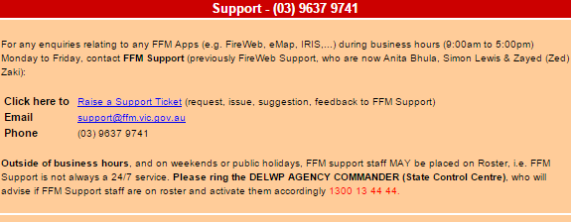

Reference Material
Document Name | Location
EMV Operational Resourcing Guidelines | EMCOP, Library, IMT Toolbox, IMTTB-Planning, Resources
EMV Operational Resourcing Aide Memoir | EMCOP, Library, IMT Toolbox, IMTTB-Planning, Resources
Joint Standard Operation Procedure 3.09 Resource Management | EMCOP, Library, JSOPs

Appendix 1 - Request Status Explained
Status | Meaning | Actions that can be taken
1. Draft | The user has entered some or all request details and clicked  “Save as Draft” | - The request details can be edited  - Resource types (e.g. Incident Controller, General Firefighter) can be added, edited and deleted  - The request can be printed  - The request can be submitted to the Region
2. Submitted to Region | The user has finished entering request details and resource types and clicked Submit to Region | - Call details must be added  - Attachment can be added / deleted  - Request can be Closed  (i.e. all request types have been filled and movement orders disseminated)  - Request can be Cancelled  (i.e. resources are no longer required)  - Request details and resource types cannot be changed
3. Actioning by Region | The Regional User has clicked  Start Actioning | - Call details must be added  - Request type items can be actioned by selecting/entering resource names  - Attachments can be added and removed  - Movement Order details can be entered and Movement Orders published (as PDFs)  - Request can be submitted to the SCC  - Request can be Closed  (i.e. all request types have been filled and movement orders disseminated)  - Request can be Cancelled  (i.e. resources are no longer required)  - Request details and resource types cannot be changed
4. Submitted to SCC | The Regional User is unable to fulfil the resource request and has clicked Submit to SCC | - Call details must be added  - Attachment can be added / deleted  - Request can be Closed  (i.e. all request types have been filled and movement orders disseminated)  - Request can be Cancelled  (i.e. resources are no longer required)  - Request details and resource types cannot be changed
5. Actioning by SCC | The SCC User has clicked  Start Actioning | - Call details must be added  - Request type items can be actioned by selecting/entering resource names  - Attachments can be added and removed  - Movement Order details can be entered and Movement Orders published (as pdfs)  - Request can be Closed  (i.e. all request types have been filled and movement orders disseminated)  - Request can be Cancelled  (i.e. resources are no longer required)  - Request details and resource types cannot be changed
6. Completed | The User has finishing fulfilling some or all resources on the request and has clicked  Close and Archive | - Call details must be added  - Attachment can be added  - Existing Movement Orders can be viewed and printed
7. Cancelled | The User no longer requires the resources and has clicked  Cancel Request | - Call details must be added  - Attachment can be added  - Existing Movement Orders can be viewed and printed

Appendix 2 - example of a movement order
